2088BRGB Matrix

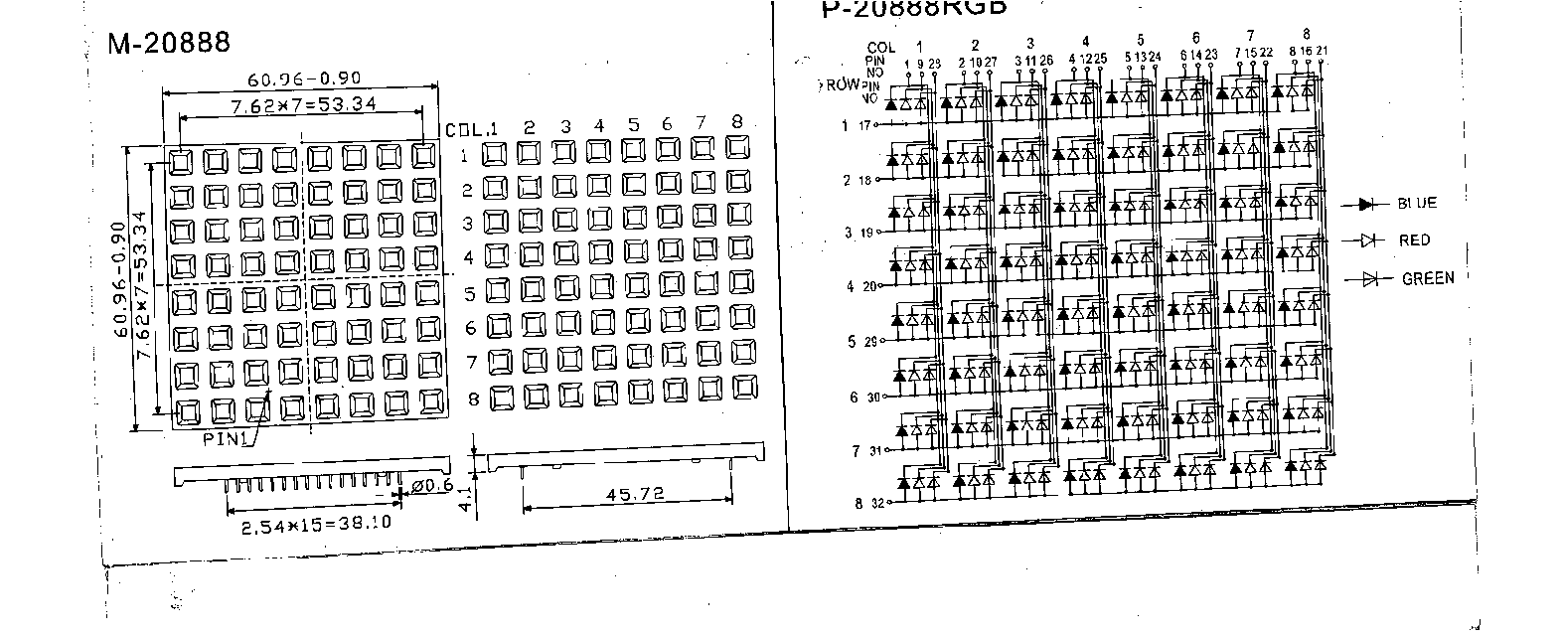
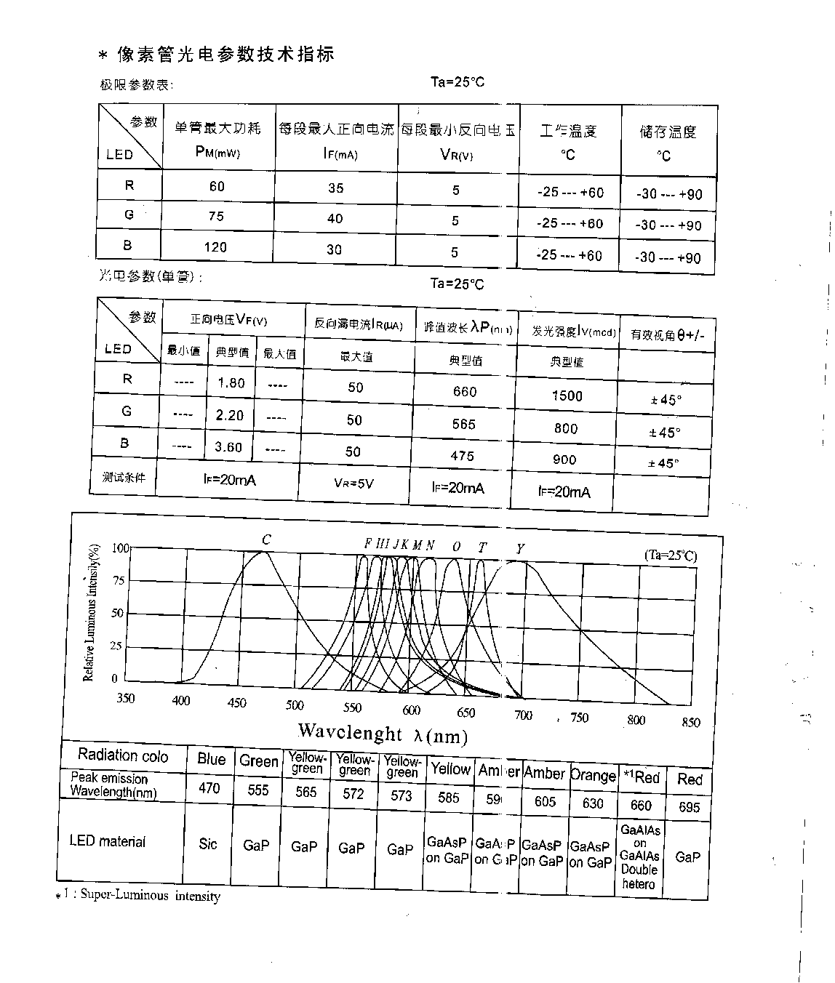
Aboslute Maxinum rating
Max.Power Consumption | Max.Forward Current | Forward Pulse Peak Current | Backward Voltage | Soldering temprature | Working temperature | Storage Temperature
PM=80MW | IFM=30MA | IFP=75MA | 5V | 260℃(<5S) | -25℃--+85℃ | -30℃--+85℃

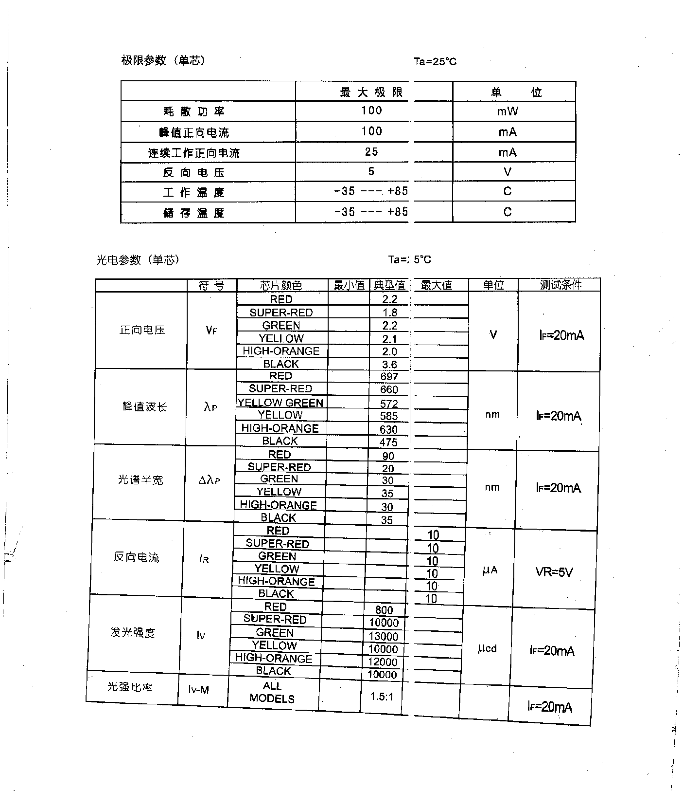

Caution:
(1)It’s required that working current should be between 10 and 20mA, and it must be below 20mA and above 5mA.
(2)Recommended working temperature: ≤60℃.
(3)Do not make it work nearby high heating device
Soldering Requirement
（1）Soldering with an iron：
Temperature: ≤300℃
Contact Time: ≤3 seconds
（2）Wave Soldering
Temperature: ≤300℃
Contact Time: ≤5 seconds

